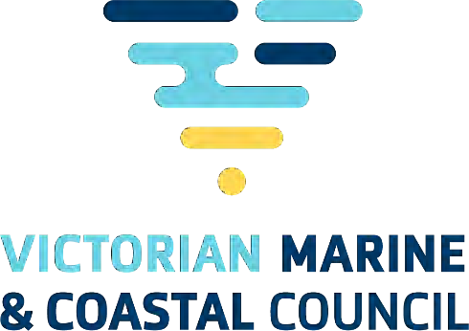

Victorian Marine and Coastal Council: Annual Report 2024–25

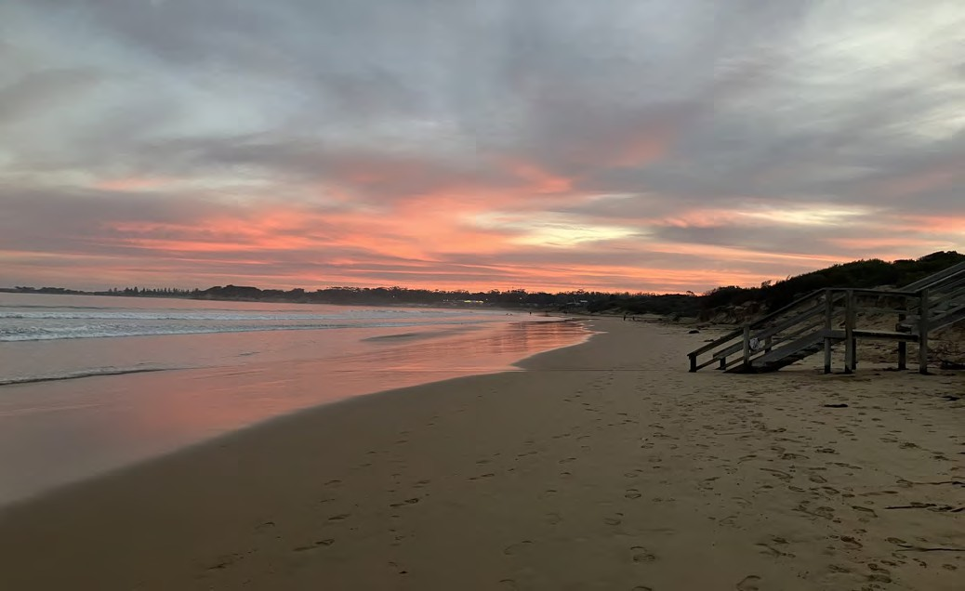


1

Prepared by the Victorian Marine & Coastal Council 8 Nicholson Street, East Melbourne, Victoria 3002
October 2025
© The State of Victoria Department of Energy, Environment, and Climate Action Melbourne 2025

This work is licensed under a Creative Commons Attribution
3.0 Australia licence. You are free to re-use the work under that licence, on the condition that you credit the State of Victoria as author. The licence does not apply to any images, photographs or branding, including the Victorian Coat of Arms, the Victorian Government logo and the Victorian Marine and Coastal Council logo. To view a copy of this licence, visit http://creativecommons.org/licenses/by/3.0/au/deed.en

Accessibility
If you would like to receive this publication in an alternative format, please telephone DEECA Customer Service Centre 136 186, email customer.service@delwp.vic.gov.au, or via the National Relay Service on 133 677
www.relayservice.com.au. This document is also available on the internet at www.marineandcoastalcouncil.vic.gov.au

Disclaimer
This publication may be of assistance to you, but the State of Victoria and its employees do not guarantee that the publication is without flaw of any kind or is wholly appropriate for your particular purposes and therefore disclaims all liability for any error, loss or other consequence which may arise from you relying on any information in this publication.

Photo acknowledgements
Contact Victorian Marine & Coastal Council Secretariat for further information.

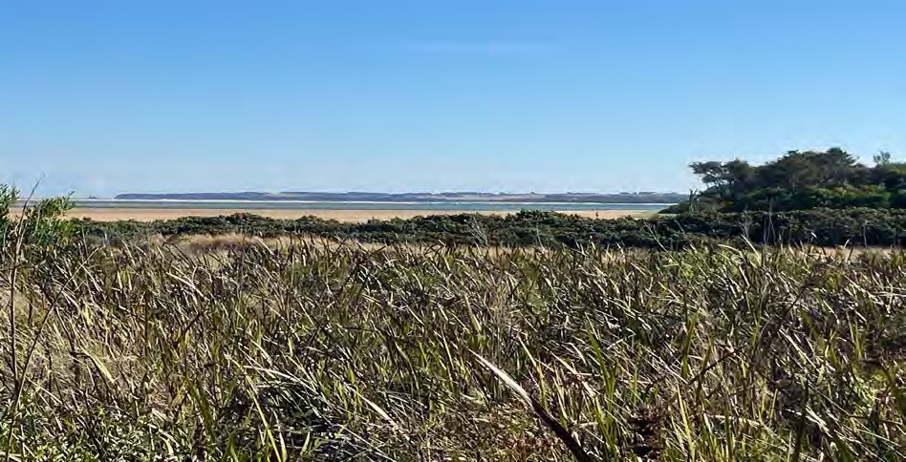
Anderson’s Inlet, Inverloch (photo credit: Ian Swan)
Front Cover: Whites Beach, Torquay (photo credit: Ian Swan) Victorian Coastal Awards photo credit: Tony Dean (Tone Productions) Council members’ photo credit: Chris McConville

We acknowledge and respect Traditional Owners across Victoria as the original custodians of land and waters, their unique ability to care for Country and deep spiritual connection to it. We honour Elders past and present whose knowledge and wisdom has ensured the continuation of culture and traditional practices. We recognise Traditional Owners’ distinct spiritual, material, and economic relationship with Sea Country. We are committed to genuinely partner, and meaningfully engage, with Traditional Owners and Aboriginal communities across Victoria to support caring for Sea Country, as well as their broader aspirations in the 21st century and beyond.




2

Contents
Responsible body declaration 4
Foreword 5
- Year in review 6
  - Council Membership 6
  - Purpose and function 7
  - Highlights and performance against functions 7
- Governance and organisational structure 12
  - Council members 12
  - Representation on stakeholder reference groups 15
  - Presentations received at Council meetings 16
  - Submissions by Council 17
  - Council publications 17
  - Statement of pecuniary Interests 17
  - Council Performance 17
  - Risk management 17
  - Occupational Health and Safety Policy 17
  - Employment and conduct principles 17
- Workforce data 18
  - Workforce Data 18
  - Women, Youth and Indigenous Affairs 18
- Other disclosures 18
  - Freedom of Information (FOI) 18
  - Making a request 18
  - Compliance with the Public Interest Disclosures Act 2012 18
  - Office-based environmental impacts 19
  - Statement of Availability of Other Information 19
  - Compliance with Data Vic Access policy 19
  - Overseas travel 19
- Council expenditure 19
  - Expenditure and financial management 19
  - Summary of Financial Operating position 19
Disclosure Index 20
Abbreviations and Acronyms 21

Responsible body declaration
The Hon. Steve Dimopoulos MP Minister for Environment
8 Nicholson St
East Melbourne VIC 3002

Dear Minister
In accordance with the Marine and Coastal Act 2018 I am pleased to present the Victorian Marine and Coastal Council Annual Report for the reporting period 1 July 2024 to 30 June 2025.
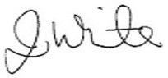
Jacquie White
Chairperson, Marine and Coastal Council 1 September 2025

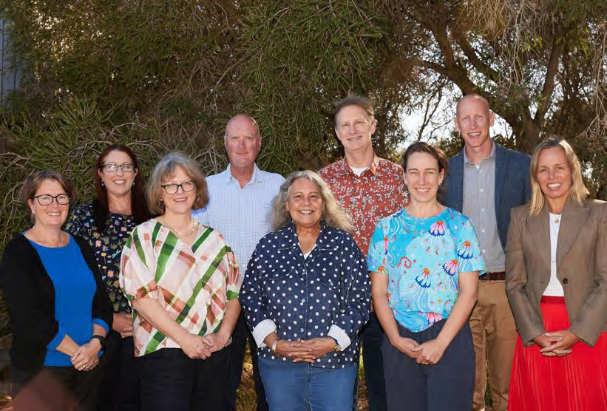

Victorian Marine and Coastal Council Members
From left to right: Dr Anna Grage, Jacquie White (Chair), Mikaela Power, Prof. Gerald Quinn, Marianne Atkinson, Dr Simon Torok, Dr Rebecca McIntosh, Martijn Gough (Deputy Chair) and Kylie Steel

Foreword
The Victorian Marine and Coastal Council was established under Section 16 of the Marine and Coastal Act 2018 and is the state’s peak advisory body on marine and coastal issues. The nine Council members bring a breadth of skills and expertise across marine conservation and ecology, coastal and catchment management, planning, tourism, sustainable fisheries, science communications, business and financial management, marketing and public sector governance, as well as extensive networks across federal, state and local government, industry, academia, not-for-profit organisations and community.
Our function under the Act is to provide independent, evidence-based and stakeholder-informed advice to the Victorian government on a range of marine and coastal matters, significant decisions affecting the marine and coastal environment, and matters requiring scientific research.
The vision for the Council is a ‘resilient and healthy marine and coastal environment, now and in the future’

The Council continues to emphasise the importance of:
- embedding Traditional Owner groups in policy and planning processes and partnerships
- evidence-based research to inform planning and adaptation practice
- effective engagement with and listening to the breadth of marine and coastal stakeholders through continuing consultation and direct reporting
- identifying and prioritising current and emerging issues and opportunities to inform the development of Council’s annual work plan
- displaying integrity, transparency and a culture of continuous improvement.
The Council has continued to facilitate understanding and application of the Marine and Coastal Policy. This includes supporting and monitoring effective application and implementation of the Marine and Coastal Strategy, and associated guidelines, tools and processes.
Council is proud of the following achievements for 2024–25:
  - 2024 Marine and Coastal Awards: A successful award ceremony was held in November 2024 to celebrate and recognise the achievements of Traditional Owners, community groups and individuals, organisations and agencies in caring for the marine and coastal environment. Nine awards were presented in front of an audience of over 150 people.
- Council members appointed/reappointed: Two new members were appointed to Council along with three reappointed members in late 2024, broadening Council’s knowledge base and
continuing the practice of high-quality appointments to the Council, which enhances its opportunity to provide quality advice to the Minister for Environment and the Department of Energy, Environment and Climate Action (DEECA).
- Strategic Planning: The Council undertook a facilitated strategic planning session in March 2025 where Council’s goals, objectives and priorities for the next 18 months were reviewed, refined and incorporated into a forward calendar of business, which was then reflected in a refreshed 2024–26 Business Plan.
- Traditional Owners: Coastal Traditional Owner groups shared with Council the importance of Sea Country Plans and how these must be recognised and integrated into marine planning and management through self-determination. Strengthening partnerships between the Council and Traditional Owners enabled meaningful collaboration, including through the newly formed Saltwater Council, where a regular Council meeting agenda item has been included to facilitate these discussions.
- Wave6 Social Research Project: The Council completed a successful procurement process in May 2025 that led to the appointment of Quantum Market Research (Aust) Pty Ltd to undertake the valuable and anticipated Marine and Coastal Community Attitudes and Behaviours Research – Wave6. The Wave6 project will provide key insights for Council, DEECA, stakeholders and partners, Traditional Owners and Ministers on community views concerning Victoria’s marine and coastal areas.

5

Year in review
  - Council Membership
The Victorian Marine and Coastal Council is established as an advisory body under the Marine and Coastal Act 2018 (the Act) to provide expert guidance and advice to the Minister on issues relating to Victoria’s marine and coastal environments.
The responsible Minister for the period was:
- The Hon Steve Dimopoulos MP, Minister for Environment.

Council Members | Member continuing,  extended, new, reappointed | Period of appointment
Dr Anthony Boxshall (Chair to 31 October 2024) | Continuing – extended | 1 August 2021 – 31 October 2024
Ms Jacquie White (Deputy Chair to 31 October 2024;  Chair from 9 Dec 2024) | Continuing – extended  Reappointed | 1 August 2021 – 31 October 2024  9 December 2024 – 31 July 2027
Ms Marianne Atkinson | Continuing – extended  Reappointed | 1 August 2021 – 31 October 2024  9 December – 31 July 2027
Dr Anna Grage | Continuing – extended  Reappointed | 1 August 2021 – 31 October 2024  9 December 2024 – 31 July 2027
Dr Rebecca McIntosh | Continuing | 1 August 2023 – 31 July 2026
Ms Mikaela Power | Continuing | 1 August 2023 – 31 July 2026
Professor Gerald Quinn | Continuing | 1 August 2023 – 31 July 2026
Ms Kylie Steel | Continuing | 1 August 2023 – 31 July 2026
Mr Martijn Gough (Deputy Chair from 9 Dec 2024) | New | 9 Dec 2024 – 31 July 2027
Dr Simon Torok | New | 9 Dec 2024 – 31 July 2027

Member | Number of Council meetings attended during the period
Dr Anthony Boxshall | 4/4
Ms Jacquie White | 7/7
Ms Marianne Atkinson | 7/7
Dr Anna Grage | 6/7
Dr Rebecca McIntosh | 8/8
Ms Mikaela Power | 7/8
Professor Gerald Quinn | 8/8
Ms Kylie Steel | 8/8
Mr Martijn Gough | 3/3
Dr Simon Torok | 3/3

  - Purpose and function
Section 16 of the Act outlines the Council’s functions and accountabilities in relation to the Responsible Minister. Council’s purpose is to provide evidence- based and stakeholder-informed advice for Ministers to enable leadership in the adaptive planning and management of Victoria’s marine waters and coastal areas.
Council uses its influence, expertise and convening powers to advocate for a healthy, dynamic and biodiverse marine and coastal environment that is valued in its own right to benefit the Victorian community, both now and into the future.
Members continue to exercise their influence, expertise and strong stakeholder relationships to build collaborative and trusted networks to progress Council’s goals.

Advice to the Minister
Council provided advice on the following marine and coastal matters through its work with DEECA on the following:
- feedback on the draft Coastal and Marine Management Plan Guidelines (CMMPs)
- contributions to the Coastal Erosion Advice Project
- ongoing advice on the development of tools and guidance under the Act, which included:
  - Marine Spatial Planning Guidelines (MSP)
  - Coastal and Marine Management Plans (CMMPs)
  - Victoria’s Resilient Coast Guidelines
  - Regional Adaptation Strategic Partnerships (RaSPs).
  - Highlights and performance against functions

    - Traditional Owner partnerships
Council is continuously seeking to strengthen the way we listen, respect Traditional Owners (as the rightsholders and custodians of land and Sea Country), deepening the partnerships, self-determination and shared outcomes for the marine and coastal environment.
Council now has a standing meeting agenda item to actively enable and support Traditional Owner participation and input to Council decisions.
This has included receiving presentations and discussions on Sea Country Plans and self- determination initiatives from local Traditional Owners during Council’s regional meetings and working with the newly formed Saltwater Council group of Traditional Owners.
    - Research and evidence base
In delivering on Council’s function under the Act to provide evidence-based and stakeholder-informed
advice, Council has undertaken the following:
Wave6 – Marine and Coastal Community Attitudes and Behaviours Research 2025
The Council released a Request For Quote in early May 2025 seeking suitable firms to undertake the next in the series of ‘Wave’ projects to undertake social research into Victorian community attitudes and behaviours relating to our marine and coastal environments.
Following an extensive and thorough evaluation process, Quantum Market Research (Aust) Pty Ltd (QMR) was recommended as the preferred supplier in mid-June 2025. The work that QMR will be undertaking forms part of the ongoing social research surveys that have been undertaken over the years, to build a long- term understanding of community values and behaviours in relation to marine and coastal use and management.
As the last ‘Wave’ social research project was conducted in 2018, Wave6 is intended as a smaller, more focused iteration. Its key purpose is to provide current, relevant insights into how communities are using, valuing, and interacting with the coast and marine environments today. It is expected that the findings and outcomes of this key piece of research will be available by the end of August 2025.
The Expert Advisory Panel
Council’s Expert Advisory Panel (EAP) comprises scientists and other experts representing a broad range of disciplines to provide independent, strategic, scientific advice to the Council on emerging marine and coastal issues and knowledge gaps.
Council will be working with EAP members over 2025– 26 to:
- continue to bring emerging science and research to inform Victoria’s marine and coastal management
- contribute to the discussion on sea level rise and coastal hazard risks
- participate in Council meetings and events as required.
    - Stakeholder informed approach
In delivering on its function to provide stakeholder- informed advice, Council has engaged with a diversity of individuals, groups, organisations and agencies involved in marine and coastal management.
To support this, Council has conducted its meetings across regional and metropolitan coastal towns, ensuring in-person conversations with Traditional Owners, land managers and communities. This approach has enabled a breadth of perspectives and voices to be shared with Council, supporting advice to the Minister and government on the opportunities and challenges for Victoria’s marine and coastal environment.

    - 2024 Marine and Coastal Awards
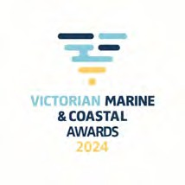
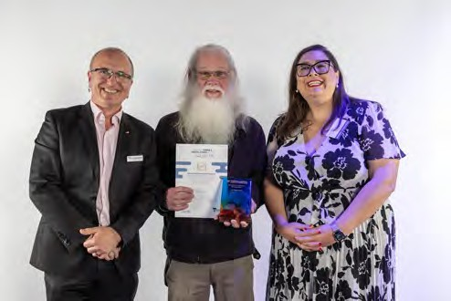
Joint winner of the Individual Achievement Award, Neil Blake OAM (centre), with Anthony Boxshall (former Council Chair) and Sheena Watt MP.
The Victorian Marine and Coastal Awards were held on 7 November 2024 on Wurundjeri Country at Showtime Events Centre in South Wharf, Melbourne.
The Awards recognised the outstanding efforts and achievements of coastal leaders and communities across Victoria and were an opportunity to celebrate the many people, partnerships and organisations protecting and managing the coastal and marine environment for future generations.
Over 150 guests from the marine and coastal sector, including community members, Traditional Owners, universities, Coastcare groups, Committees of Management, not-for-profit organisations, local councils, state government departments and agencies, as well as private landowners and private companies came together to celebrate our treasured coast.
Guests were welcomed to Country by Wurundjeri Elder Bill Nicholson, with Sheena Watt MP, Member for Northern Metropolitan, presenting the trophies to this year’s winners on behalf of the Hon. Steve Dimopoulos, Minister for Environment.
The 2024 Awards attracted 43 diverse and impressive nominations across six categories, with the following winners:

Leadership in Climate Adaptation and Resilience
South Gippsland Shire Council for ‘The South Gippsland Coastal Strategy’

Excellence in marine and coastal design or development
City of Greater Geelong for ‘The Dell Eco Reef, Clifton Springs’

Distinction in biodiversity and ecosystem conservation
The Nature Conservancy Australia for ‘Reef Builder’

Inspiring community engagement and education (professional agencies, large organisations and industry)
Dolphin Research Institute for ‘i sea, i care’

Inspiring community engagement and education (community and volunteer groups/individuals)
Friends of Griffiths Island – Port Fairy for ‘Switch off for Shearwaters – Light Pollution Management’

Embedding Traditional Owner cultural practices in management
Wadawurrung Traditional Owners Aboriginal Corporation for ‘Bukareeyoo – Returning Language to
Country’

Recognising emerging leadership
Juliet Bảo Ngọc Doling

Recognising individual achievement
Joint-winners Neil Blake OAM and Mark Rodrigue

Special award for service
Dr Anthony Boxshall

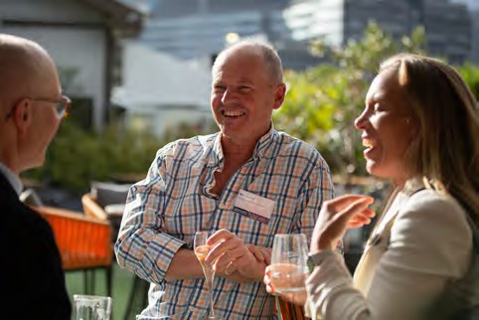

    - Highlights against Council functions
Section 16 of the Act includes 11 functions for the Council. These functions are outlined below, including a high-level summary of deliverables against each from 1 July 2024 to 30 June 2025.

Functions | Deliverable
Function (a) and (b)  Marine and Coastal Policy and Marine and Coastal Strategy development and implementation | The Council worked closely with DEECA in developing tools for the development and implementation of the Marine and Coastal Policy and Strategy. These tools include  - Feedback on the draft Coastal and Marine Management Plan Guidelines (CMMPs)  - Contributions to the Coastal Erosion Advice Project  - Ongoing advice on the development of tools and guidance under the Act. These included:  - Marine Spatial Planning Guidelines (MSP)  - Coastal and Marine Management Plans (CMMPs)  - Victoria’s Resilient Coast Guidelines  - Regional Adaptation Strategic Partnerships (RaSPs)
Function (c)  Provide advice to the Minister on significant decisions under the Act | The Council maintained a proactive approach in ensuring the Minister and the Minister’s office were kept informed of the Council’s activities and current marine and coastal issues, including:  - meeting held with the Minister, Council Chair and Deputy to provide a briefing on Council’s proposed Business Plan including Wave6 social research project (26 March 2025)  - provision of findings and advice on community sentiment in managing sea level rise following Council’s regional meeting in Inverloch (via email)  - report on Marine and Coastal Awards, notifying Minister of award recipients and showcase of excellence in marine and coastal management  - engagement in the development of key survey and focus group themes for the new Wave6 marine and coastal communities’ behavioural and attitudinal study.
Function (d)  Matters requiring scientific research | The EAP was engaged where resources permitted, which continued to support the development of Council members' knowledge and skills, including Council member attendance and involvement in several state and national events and organisations.  Member attendance at conferences, seminars and meeting is detailed at item 1.4.6
Function (e)  Provide advice on guidelines prepared under the Act | Council has previously provided advice on preparing the Coastal and Marine Management Plan guidelines and Victoria’s Resilient Coast guidelines. Council has not received any requests for advice on guidelines during the reporting period.
Function (f) and (g)  Request the Minister establish Regional and Strategic Partnerships (RaSP) & provide advice to participants | Council has previously provided advice to DEECA regarding the proposed Cape to Cape RaSP.  During this reporting period Council was not requested to provide advice on any potential RaSPs, nor did Council request the establishment of any RaSPs.
Function (h)  Provide input to the preparation of Environmental Management | The Port Phillip Bay EMP is the only EMP that has been established under the Act. As a member of the Port Phillip Bay EMP Senior Agency Reference Group, the Council provides advice (as required) on the priorities and emerging issues or risks that may impact the EMP’s implementation. Council’s advice on the

Plans (EMP) under the Act | Port Phillip Bay EMP has not been sought during this reporting period.
Function (i)  Matters relating to or affecting the administration of the Act | Council continues to support the implementation of the Marine and Coastal Strategy and adherence to the Marine and Coastal Policy as the key documents guiding administration of the Act.  Council has had no requirement to, nor reason to, draw the Minister’s attention to any specific matters relating to, or affecting, the administration of the Act during the reporting period.
Function (j)  Carry out any other function conferred on VMaCC by or under the Act or any other Act | The Act is supported by the Marine and Coastal Policy and the Marine and Coastal Strategy, which reflect the objectives and guiding principles set under the Act and are complemented through a program of reforms and actions over the coming years.  As Council has an oversight and independent advisory function, it can play an important role in ensuring these reforms and actions are carried out, along with ensuring Traditional Owner voices, stakeholders and the coastal communities are heard.
(2) In performing its functions VMaCC must have regard to the principles and objectives of the Act. | Council’s vision is aligned with that of the Policy: ‘For a healthy, dynamic and biodiverse marine and coastal environment that is valued in its own right, and that benefits the Victorian community, now and in the future’.  The objectives of the Act relate to planning and management of the marine and coastal environment. They define rights and aspirations and set measures and arrangements designed to ensure these are met. Council is conscious of always considering the principles and objectives of the Act in its decisions, activities and advice.

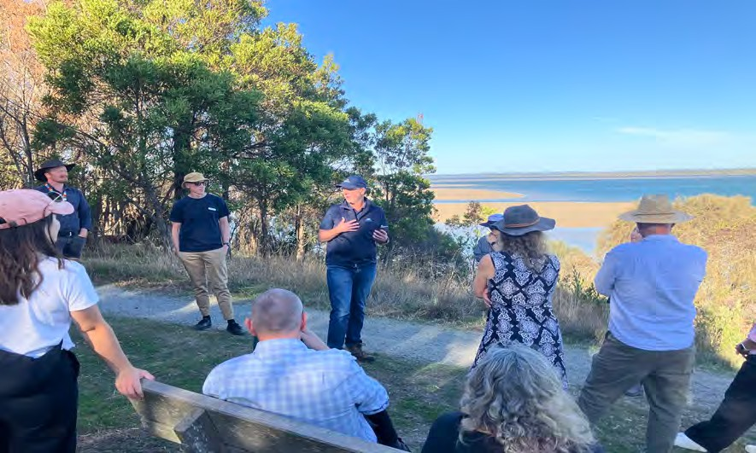
‘Coastal Walk and Talk’ with land managers from the local Catchment Management Authority and local government.
Anderson’s Inlet, Inverloch (photo credit: Ian Swan)

    - Conferences and seminars attended by Council members
Council members attended the following conferences, seminars or workshops as part of their role.

Event Name | Event Focus | Member Name | Date
Victorian Landcare Awards | 2024 Victorian Landcare Awards Ceremony | Dr Anthony Boxshall | July 2024
DTF New Directions in Economic Policy | Economic Impacts from Sea Level Rise and Storm Surge in Victoria | Dr Anthony Boxshall (as presenter) | 23 July 2024
National Partnership for Climate Projections | Moderated session for National Partnership for Climate Projections | Dr Anthony Boxshall (as presenter) | 16 Aug 2024
Commissioner for Environmental Sustainability (CES) | EY Review of the relationships and outputs of the CES | Dr Anthony Boxshall | 11 Sept 2024
CMA CEOs Meeting | Catchment Management Authorities | Kylie Steel | 7 Nov 2024
Victorian Waterway Strategy Peak Body Group Meeting | Discussion of Draft Vic Waterway Management Strategy, Parts 1-7 | Rebecca McIntosh | 12 Dec 2024
U3A Warrnambool University of the Third Age & Deakin University | Coastal Hazards and Coastal Management in a Time of Rapid Climate Change | Gerry Quinn | 16 April 2025
Local Government Roundtable | Victorian Coastal Councils 2025: Building an integrated approach to coastal risk and planning for local government | Jacquie White | 15 May 2025
Marine and Coastal Strategy | Action showcase: sustainable use and development of the marine and coastal environment | Simon Torok Rebecca McIntosh Anna Grage  Kylie Steel | 29 May 2025
Australian Offshore Wind Industry Forum | Overview of Victoria's offshore wind industry, exploring the opportunities in both domestic and international markets. | Mikaela Power Anna Grage | 3 Jun 2025
Joint National Coast to Coast and QLD Coastal Conference | Using past experience and incorporating emerging knowledge to support future resilient coastal communities. | Jacquie White Kylie Steel | 4–6 June 2025
National Marine Science Committee Symposium | Shaping Australia’s next National Marine Science Strategy (2025–35). | Rebecca McIntosh | 18–20 June  2025

    - General Business activities
Council’s general business activities broadly involved:
      - advising and meeting with the Minister for Environment and their office on a regular basis
      - expanding opportunities to engage with coastal Traditional Owners to progress partnerships, self determination and also to support and enable a First Nations’ voice to be considered as part of Council’s business
      - meeting with rightsholders, stakeholders and partners through discussions, participating in working groups and holding selected Council meetings in regional coastal towns
      - progressing and finalising the procurement of the Wave6 project that will provide insights on contemporary community sentiment on marine and coastal issues, complementing previous research and enhancing advice to the Minister
      - providing feedback to DEECA and lead agencies
on key policy and guidelines.
1.4.8 Council’s Business Plan
Council’s Strategic Business Plan 2024–26 provides a clear vision and strategic direction for its future activities.
Due to member reappointment processes during this period and internal resourcing changes, Council undertook a mid-cycle review of its Business Plan to re- establish focus areas and deliverables for the next two years.
The Business Plan retains a focus on supporting and monitoring the effective application and implementation of the Marine and Coastal Policy and the Marine and Coastal Strategy but will prioritise Traditional Owner partnerships, stakeholder feedback and sector knowledge sharing and capability development.

Governance and organisational structure



The Council is resourced with budget and Secretariat support through DEECA. On 30 June 2025 the Council was supported by two staff (up to 1.7 full-time equivalent).
EXECUTIVE OFFICER
Ruth Cockerton (0.8 FTE) 1 July 2024 - 21 April 2025
Ian Swan 22 April - 30 June 2025
PROJECT SUPPORT OFFICER
Franziska Taylor (0.7 FTE)
Both professional experience and capacity in networking and stakeholder engagement are key considerations for appointment to the Council. This has seen a high calibre of membership whose expertise covers a broad range of marine and coastal disciplines. This expertise, combined with stakeholder-informed evidence, provides the basis of high-quality advice to the responsible Minister.

Figure 1: Victorian Marine and Coastal Council Secretariat Organisational Structure
Council’s office is located at 8 Nicholson Street, East Melbourne, Victoria 3002.
The postal address for the Council is:
PO Box 500, East Melbourne Victoria 8002. Telephone: 9637 8893
Email: vmacc@deeca.vic.gov.au

Website: www.marineandcoastalcouncil.vic.gov.au
  - Council members
Appointments to the Council are made under the provisions of the Marine and Coastal Act 2018 by the Minister for Environment.
Dr Anthony Boxshall (Chairperson to 31 October 2024) is a marine ecologist who has worked in Australia and the USA across Government, academia and the private sector. He is the Founder and Principal of Science

into Action Pty Ltd, a science impact company turning science into action. He is a Board Director of Parks Victoria and was the valedictory Chair of the Victorian Coastal Council. A former National President of the Australian Marine Sciences Association (AMSA), he has worked at UC Santa Cruz USA, Deakin University, and has been on several innovation Boards. A current Melbourne Enterprise Fellow in the School of Biosciences at the University of Melbourne, he ran the Science area at the Environment Protection Authority (EPA) in Victoria for nearly a decade.
Anthony has communicated the wonders of the marine and coastal environment to a broad audience through the award-winning “Radio Marinara” on 3RRR-FM in Melbourne for more than 27 years. He is a dad to four children who continually amaze, inspire, frustrate and leave him in awe of the potential of the future and

hence more determined to leave a positive coastal and marine legacy.

Ms Jacquie White (Deputy Chair to 31 Oct 2024; Chairperson from 9 Dec 2024)
Ms Jacquie White has over
20 years’ experience working in the environment sector across coastal management, catchment management, integrated water management, community and stakeholder engagement, organisational change and
capacity building, and social research and evaluation. She is currently the Executive Officer of the Association of Bayside Municipalities and runs a consultancy providing event management and stakeholder engagement services. Jacquie’s previous professional roles included: General Manager of the Environment Institute of Australia and New Zealand, Manager Community Programs at Melbourne Water, Director at the Office of Living Victoria, and Manager of Organisational Transformation with the Country Fire Authority.

Ms Marianne Atkinson
Marianne Atkinson’s professional working history captures the areas of Government, Human Services, Education & Training, Family Violence Policy, Systems & Reform, Aboriginal Affairs, and community organisations. Ms Atkinson is an expert in developing policy and strategy, providing advice to government, and regional
and strategic partnerships, and working with community members as well as professionals to codesign and develop effective processes for the evaluation and validation of programs, systems, and structures.
She has broad experience leading, coordinating and liaising with community groups and preparing and facilitating state-wide strategies in response to community needs, improving outcomes to adapt new practices and systems, progressing ideas and transforming thoughts into action-driven solutions.
Ms Atkinson is employed part-time at RMIT University, Melbourne, as VE Tutor of the Diploma of Community Services. Her fields of study include Business, Business Analytics, Education, and Data Analysis. She is currently the Co-Chairperson of the Aboriginal Torres Strait Islander Advisory Group (National
representatives), Australian War Memorial and the Gunaikurnai Traditional Owner Land Management.

Dr Rebecca McIntosh
Dr Rebecca McIntosh is a Marine Scientist at Phillip Island Nature Parks. She has over 20 years’ experience specialising in marine mammals and avian ecology, anthropogenic change, wildlife monitoring and threatened species management.
Dr McIntosh is a former Senior Researcher at South
Australian Research and Development Institute. Dr McIntosh has worked on the ecology and demography of marine predators for over 20 years, with a focus on Australian seals. She holds a Bachelor of Science and a Doctor of Philosophy in population biology. Dr McIntosh demonstrates a comprehensive understanding of climate change adaptation, the coastal and marine industry, conservation, marine science and policy, risk management and community and stakeholder engagement.


Dr Anna Grage
Dr Anna Grage has a background in marine environmental law and planning, and urban and environmental statutory planning. She has a Bachelor of Laws, a Bachelor of Planning and Design (Hons), and a PhD (University of Wollongong) that focuses on Australian legal frameworks for marine environmental
impact assessment. Anna has worked as a lecturer at the Australian Maritime College/University of Tasmania, teaching in the areas of international ocean governance, environmental advocacy, and marine environmental and fisheries law and policy.
Anna has worked in Victoria and Western Australia as a statutory planner for local government, and as a solicitor in the areas of planning and environmental law, with her most recent local government role being with Mornington Peninsula Shire. Anna is currently a Visiting Research Fellow at the University of Adelaide, Principal Consultant of Earth-Sea Planning, and a volunteer for the Sea Search (Parks Victoria) program/Friends of Mushroom Reef Marine Sanctuary, and the Country Fire Authority.


Ms Mikaela Power
Ms Mikaela Power is an experienced senior public and private sector leader. She is Associate Director Partnerships and Growth at Federation University and a former senior executive at TAFE Gippsland. Ms Power was a Baw Baw Shire Councillor from 2012 to 2020, Mayor in 2019 and a former Deputy Chair of the Peri-
urban Group of Rural Councils.
Ms Power brings skills and experience in local government, public sector governance and administration, an understanding of the law, policy and obligations in relation to Traditional Owners, community and stakeholder engagement and strategic planning. She is Chair of the West Gippsland Catchment Management Authority.

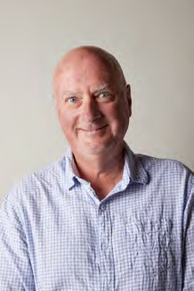
Professor Gerald Quinn
Professor Gerald Quinn is the former Head of the Warrnambool Campus of Deakin University (2012–15) and former Chair in Marine Biology, School of Life and Environmental Sciences, retiring in 2020. He is a current Chairperson in Marine Biology at Deakin University and has served on several statutory bodies,
advisory committees and government public entities. He has extensive research experience in coastal marine ecology, freshwater ecosystems and the effects of flow change on rivers and wetlands. He is a current board member at Glenelg Hopkins Catchment Management Authority.
Professor Quinn holds a Bachelor of Science in Zoology, a Doctor of Philosophy in Marine Biology and has completed the Australian Institute of Company Directors Course. Professor Quinn demonstrates a comprehensive understanding of climate change adaptation, the coastal and marine industry, conservation, marine science and policy, risk management, community and stakeholder engagement, strategic thinking and planning.
Ms Kylie Steel
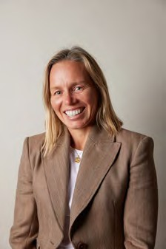
Ms Kylie Steel is the founder and director of SCB Consult, a consultancy specialising in climate change, bushfire science and emergency management. She has been a board director on Southern Rural Water since 2019, and on Barwon Health Foundation since 2017. She was a board member and Deputy Chair on the Great Ocean Road Coast
Committee from 2013–20. Ms Steel holds qualifications in business, company directorship, bushfire planning and management and science. Ms Steel demonstrates a comprehensive understanding of climate change adaptation, the coastal and marine industry, conservation, local government, town planning, marine science and policy, public sector governance and administration, risk management, community and stakeholder engagement and strategic planning.


Mr Martijn Gough (Deputy Chair 9 Dec 2024)
Mr Martijn Gough is an economist and public policy expert with 12 years of executive and management experience in climate change adaptation, natural resource management and resilience. He is currently an Associate Director at Ricardo, leading the Resilience, Adaptation and
Nature business area. He is a form policy manager at the Municipal Association of Victoria, a Climate Adaptation Associate at the United Nations Development Program and a Senior Economist at the Victorian Department of Treasury and Finance. Martijn also has directorship experience as a former member of the NSW Coastal Council. He holds a Bachelor of Commerce (Economics) and a Bachelor of Arts (Human Geography).

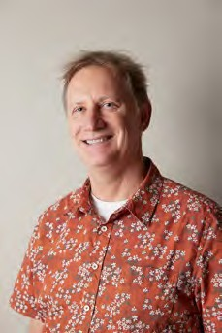
Dr Simon Torok
Dr Torok is the Director and co-founder of Scientell Pty Ltd, and an Honorary Fellow with the University of Melbourne’s School of Earth Sciences. He has worked in science communication for 30 years, including 13 years managing climate and marine communication for the Commonwealth Scientific and Industrial Research Organisation
(CSIRO). Dr Torok has co-authored 20 popular science and climate change books and made numerous appearances on television and radio.
He has a Graduate Diploma in Science Communication from the Australian National University and completed a PhD in climate change science at the University of Melbourne.

Representation on stakeholder reference groups
Council was a member on the following stakeholder reference groups during the 2024–25 financial year :
- Commissioner for Environmental Sustainability Reference Group (OCES) – Dr Anthony Boxshall to 31 Oct 2024
- Senior Stakeholder Advisory Committee on Nature Based Coastal Defence – Anna Grage
- Port Phillip Environmental Management Plan Stakeholder Reference Group – Jacquie White
- Yoorrook Justice Commission – Jacquie White

Council sub-committees
Council established two sub-committees during this period:
- Communications and Engagement Sub Committee;
- Expert Advisory Panel Sub-Committee.
As part of its refreshed business plan, Council will be reviewing the nature and function of sub-committees required to support its activities over the next 12 months.

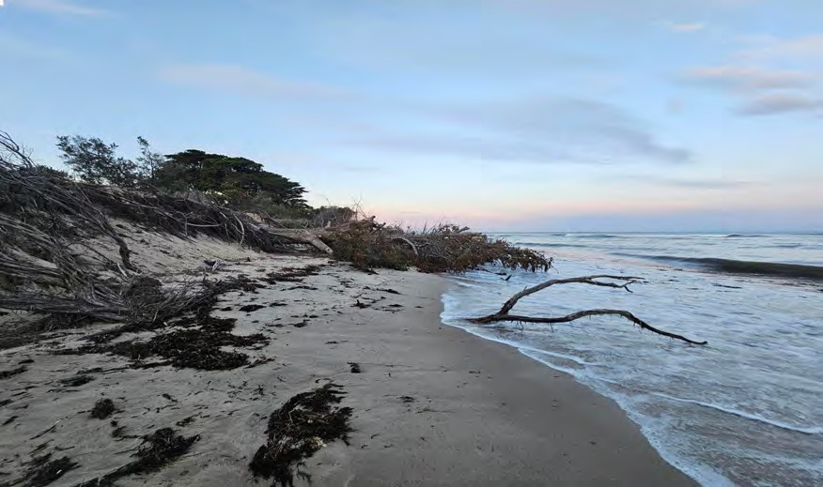

Inverloch Beach (photo credit: Franzi Taylor)

  - Presentations received at Council meetings
Council received the following presentations at its meetings over 2024–25:

Presenter | Topic | Date
Will Guthrie, Director Marine, Coast & Land Policy, DEECA  Nicola Waldron, Manager Policy & Strategy, DEECA | DEECA update on current priorities, funding opportunities and marine and coastal matters. | 15 July 2024
Elisa Zavadil, Manager Regional Coastal Adaptation and Planning, DEECA | DEECA update on Regional Coastal Adaptation and Planning, the Cape to Cape Regional and Strategic Partnership (RaSP) and Adapt West – Port Phillip Bay Western Shoreline RaSP. | 15 July 2024
Ruth Caldwell, A/Regional Director Barwon South-West, DEECA  Will Guthrie, Director Marine, Coasts and Land Policy, DEECA | DEECA Update on the Coastal and Marine Program for 2024–25 | 22–23 Aug 2024
Claire Maher, Advisor, Office of Steve Dimopoulos MP, Minister for Environment | Discussion with the Minister’s Office on Council functions and Minister’s expectations | 22–23 Aug 2024
Dan Garlick, Executive Manager, West Gippsland Catchment Management Authority  Anna Lucas, A/General Manager, Service Strategy, Melbourne Water | Discussion with coastal land and environment managers | 22–23 Aug 2024
Diana Whittington, A/Manager Development, Bass Coast Shire  Michael Jansen, Manager Sustainability and Waste, City of Casey  Duncan Turner, Manager Planning & Design, Cardinia Shire Council | Discussion with Local Government re coastal matters | 22–23 Aug 2024
Chris Padovani, Manager Stakeholder Engagement & Reform, Victorian Fisheries Authority | Discussion with Fisheries and marine matters | 22–23 Aug 2024
Shannon Hurley, Nature Conservation Campaigner, Victorian National Parks Association VPNA  Mel Barker, CEO, Western Port Biosphere Foundation | Discussion with Victorian National Parks Association and Western Port Biosphere Foundation on marine and coastal matters | 22–23 Aug 2024
Shani Blyth, Balit Biik Manager, Bunurong Land Council Aboriginal Corporation  Adam Magennis, Cultural Landscapes Coordinator, Bunurong Land Council Aboriginal Corporation | Discussion with Bunurong Land Council Aboriginal Corporation and boat trip around Western Port Bay | 22–23 Aug 2024
Helen Vaughan, Interim Commissioner for Environmental Sustainability  Scott Rawlings, Director, Science and Reporting, Office of the Commissioner for Environmental Sustainability | Update on the development of the State of the Marine and Coastal Environment 2024 Report. | 16 Sept 2024
Will Guthrie, Director, Marine Coast and | DEECA introduction with Director Marine, Coasts | 10 Feb 2025

Land Policy, DEECA | and Land Policy
Seb Chapman, Executive Director, Land and Environment Policy, DEECA  Will Guthrie, Director, Marine Coast and Land Policy, Regions, Environment, Climate Action and First Peoples Group, DEECA | Horizon scan with DEECA Executives | 24–25 March 2025
Helen Vaughan, Commissioner for Environmental Sustainability | Horizon scan with Commissioner for Environmental Sustainability | 24–25 March 2025
Darrin McKenzie, Regional Director Gippsland, DEECA | DEECA update on current and emerging regional issues | 5–6 May 2025  Inverloch
James Todd, Chief Biodiversity Officer, Arthur Rylah Institute, DEECA | Outlining potential involvement of the Council in the National Sustainable Ocean Plan and Pt Phillip Bay EMP | 5–6 May 2025  Inverloch
Lana Kovac, Director Climate Resilience and VPS Action, DEECA | DEECA update in the Climate Action Framework, adaptation and Public Private Partnerships | 5–6 May 2025  Inverloch
Elisa Zavadil, A/Regional Director, Barwon South-West, DEECA | DEECA update on current and emerging regional issues | 5–6 May 2025  Inverloch
Saltwater Council: Shani Blyth, Bunurong Land Council, Mandy Watson, Eastern Marr Aboriginal Corporation, Walter Saunders, Senior Policy Officer, DEECA | Overview and update on activities and focus of the newly formed Saltwater Council | 5–6 May 2025  Inverloch
Marine and Coastal Land Managers | ‘Walk and Talk’ discussion on marine and coastal issues with West Gippsland CMA, Bass Coast and South Gippsland Shires | 5–6 May 2025  Inverloch

  - Submissions by Council
No submissions were made during the reporting period.
  - Council publications
As part of the 2024 Victorian Marine and Coastal Awards Council published a booklet showcasing the finalists and an overview of their award-winning projects and achievements. The booklet is also published on Councils’ website.
  - Statement of pecuniary Interests
All members of the Council and the Executive Officer have completed declarations of pecuniary interest for the current reporting period, including details of any shares held by members.
  - Council Performance
An internal review of Council’s performance has been scheduled for the latter half of 2025. This will build on the outcomes of Council’s previous review held in the first quarter of 2024.
  - Risk management
While Council assesses the risks associated with the delivery of its work functions and objectives on an ongoing basis, it relies on DEECA’s risk management framework and internal audit of financial and other administrative systems used by Council’s Secretariat as outlined in the DEECA Annual Report.
  - Occupational Health and Safety Policy
Council’s operations are managed in accordance with DEECA procedures and guidelines for occupational health and safety, industrial relations, and related issues as outlined in the DEECA Annual Report.
  - Employment and conduct principles
The Council utilises DEECA’s employment processes. Both the Council and DEECA are committed to applying merit and equity principles when appointing staff. Selection processes ensure applicants are assessed and evaluated fairly and equitably based on the key selection criteria and other accountabilities without discrimination. Employees have been correctly classified in workforce data collections.
Consistent with requirements of the Public

Administration Act 2004, Council has adopted a range of policies designed to promote good governance in all its decision-making and operations. These policies comprise:
    - Code of Conduct
    - Conflict of Interest

Workforce data
  - Workforce Data
On 30 June 2025, Council was supported by two staff (1.7 full-time equivalent). Across the year, the proportion of women employed was between 50 and 100 per cent. The staff are employed by DEECA and are included in DEECA’s workforce data in the DEECA annual report.
  - Women, Youth and Indigenous Affairs
Council is committed to involving Victoria’s community, including women, youth and Aboriginal

Other disclosures
  - Freedom of Information (FOI)
The Freedom of Information Act 1982 (FOI Act) allows the public a right of access to documents held by the Council. The purpose of the FOI Act is to extend as far as possible the right of the community to access information held by government departments, local councils, Ministers and other bodies subject to the FOI Act.
An applicant has a right to seek information on any aspect of Council’s operations. This comprises documents created by the Council or supplied to it by an external organisation or individual.
The FOI Act allows the Council to refuse access, either fully or partially, to certain documents or information. Examples of documents that may not be accessed include Cabinet documents, some internal working documents, law enforcement documents, documents covered by legal professional privilege (such as legal advice), personal information about other people and information provided to Council in-confidence.
No FOI requests were made to the Council during the reporting period.
  - Making a request
The Council uses DEECA’s FOI processes.

Ways to Apply:
Online: Submit via FOI Online
Email: Send to foi.unit@deeca.vic.gov.au. You’ll re- ceive a payment form to complete via BPAY or at a post office
- Dispute Resolution
- Gifts, Benefits and Hospitality
- Meetings and Decision-making
- Performance Assessment.
All policies are available online at Council’s website.

Victorians in the planning, management and enjoyment of the coast.
The Act identifies actions to implement indigenous cultural outcomes and to improve communications with Aboriginal communities in coastal areas. Council’s Business Plan includes actions to strengthen community involvement in coastal planning and management and Council operates in an environment that ensures equity of processes and participation by rights and stakeholders.

Post: Use the FOI Application form (PDF, 897.2
KB) or accessible version (DOCX, 696.5 KB) and send to:
FOI and Privacy Unit
Department of Energy, Environment and Cli- mate Action
PO Box 500
EAST MELBOURNE VIC 8002
A non-refundable application fee is required. Council and DEECA aim to provide access in the most efficient, cost-effective way possible. If your request is unclear, Council or DEECA may ask for clarification.
You’ll receive a decision within 30 days of your valid request (or after clarifications or deposits).
If access is refused, DEECA will explain the reasons and your rights to appeal. In some cases, your request may be referred or transferred to another agency.
  - Compliance with the Public Interest Disclosures Act 2012
The Public Interest Disclosures Act 2012 (the PID Act) enables people to make a disclosure about corrupt or improper conduct by a public officer or a public body. The Council is a public body for the purposes of the PID Act.
What is a public interest disclosure?
A public interest disclosure is a complaint regarding corrupt or improper conduct or detrimental action by a public officer or a public body.
‘Improper or corrupt’: conduct that involves substantial mismanagement of public resources, risk to public health or safety or the environment, or corruption.

‘Detrimental action’: is action taken against a person in reprisal for making a public interest disclosure.
How do I make a public interest disclosure?
You can make a public interest disclosure about Council or its board members, officers or employees by contacting the Independent Broad-Based Anti- Corruption Commission (IBAC) Victoria
Address: Level 1, North Tower, 459 Collins Street, Melbourne, Victoria 3000.
Mail: IBAC, GPO Box 24234, Melbourne, Victoria 3001
Internet: https://www.ibac.vic.gov.au/ Phone: 1300 735 135
Council has established procedures for the protection of persons from detrimental action in reprisal for making a public interest disclosure about the Council, its members, officers or employees. Council is not able to receive public interest disclosures.
You can access Council’s procedures on its website at: About the Council
  - Office-based environmental impacts
Council makes use of DEECA offices and facilities to perform its functions. The reporting requirements of the office are met by DEECA. Council’s Secretariat participates fully in a range of environmental programs operating within DEECA.
  - Statement of Availability of Other Information
Other information held at Council’s office is available on request, subject to the FOI Act.

Council expenditure
  - Expenditure and financial management
Council’s operating budget is provided within the budget of DEECA. The financial operations of the Council are not separately audited and are incorporated into the overall audited financial statements of the DEECA Annual Report for the year ended 30 June 2025. Council is not required to establish a separate Audit Committee.
DEECA undertakes an annual assessment of financial management compliance with all applicable requirements of the Financial Management Act 1994, and its Standing Directions and Instructions. This includes the financial management of Council’s activities. DEECA also periodically audits this compliance.
The following table shows the operating expenditure of the Council for the 2024–25 financial year (excluding salaries and any agency staff costs) and provides a comparison with the previous year.
  - Compliance with Data Vic Access policy
Consistent with the Victorian Government’s DataVic Access policy, Council intends that any data tables which it may produce will be available in machine- readable format at: http://data.vic.gov.au/.
  - Overseas travel
There was no overseas travel by Council members for Council purposes in the reporting period.
  - Compliance with the Building Act 1993
The Council makes use of buildings and facilities controlled by DEECA to perform its functions and does not own or control any buildings.
  - Local Jobs First
For the 2024-2025 reporting period, the Council did not undertake any projects subject to Local Jobs First Act 2003
  - Gifts, Benefits and Hospitality Attestation
I, Ian Swan, Executive Officer of the Victorian Marine and Coast Council, certify that:
    - my public entity has policies and procedures in place that are consistent with the minimum requirements and accountabilities outlined in the Gifts, Benefits and Hospitality Policy Framework issued by the Public Sector Standards Commissioner; and
    - staff are informed about these gifts, benefits and hospitality policies and procedures.

  - Summary of Financial Operating position

Financial Year | Council operations*
2024–25 | $216,016**
2023–24 | $154,614
* Includes all members’ sitting fees, reimbursements, payroll tax, superannuation contribution, WorkCover levy, secretariat expenses, training and items such as annual report, consultants, graphic design and forums.
** Includes costs to stage the 2024 Marine and Coastal Awards, in addition to Council’s baseline expenditure
    - Consultancy expenditure
Council expended $14,520 (inc. GST) during the 2024– 25 period on the engagement of ‘Deliberate Impact’ consulting to facilitate Council’s strategic planning workshop.
    - Government advertising
Nil

19

DISCLOSURE INDEX
The 2024-2025 Annual Report of the Victorian Marine and Coastal Council is prepared in accordance with relevant Victorian legislation.
This index has been prepared to facilitate identification of the Council’s compliance with statutory disclosure re- quirements.

 | Legislation | Requirement | Page Nos
SD 5.2 |  | Sign Off Requirements | 4
Charter and purpose
FRD 22 |  | Manner of establishment and relevant Minister | 6
FRD 22 |  | Purpose, functions, powers and duties | 7
FRD 22 |  | Key Initiative and projects | 7
FRD 22 |  | Nature and range of services provided | 12
Management and Structure
FRD 22 |  | Organisational Structure | 12
Financial and other information
FRD 10 |  | Disclosure index | 20
FRD 22 |  | Employment and conduct principles | 17
FRD 22 |  | Occupational health and safety policy | 17
FRD 22 |  | Summary of the financial results for the year | 19
FRD 22 |  | Application and operation of Freedom of Information Act 1982 | 18
FRD 22 |  | Compliance with Building Act 1993 | 19
FRD 22 |  | Application and operation of Public Interest Disclosures Act 2012 | 18
FRD 22 |  | Details of consultancies over $10 000 | 19
FRD 22 |  | Details of consultancies under $10 000 | 19
FRD 22 |  | Disclosure of government advertising expenditure | 19
FRD 22 |  | Statement of availability of other information | 19
FRD 24 |  | Reporting of environmental data | 19
FRD 25 |  | Local Jobs First | 19
FRD 29 |  | Workforce data disclosures | 18
SD 4.5.5 |  | Risk management compliance attestation | 17
 |  | Gifts, benefits and hospitality attestation | 19
SD 4.2 |  | General information requirements | Entire docu- ment
MRO |  | Compliance with DataVic Access Policy | 19

20

Legislation
Building Act 1993 | 19
Freedom of Information Act 1982 | 18
Public Interest Disclosures Act 2012 | 18
Local Jobs Act 2003 | 19

Abbreviations and Acronyms

CMMP Coastal and Marine Management Plan
DEECA Department of Energy, Environment and Climate Action
EAP Expert Advisory Panel
FOI Freedom of Information
LSV Life Saving Victoria
OCES Office for the Commissioner of Environmental Sustainability
MERI Monitoring, Evaluation, Reporting and Improvement
MSP Marine Spatial Planning Framework
NMSC National Marine Science Committee
PPB EMP Port Phillip Bay Environmental Management Plan
RaSP Regional and Strategic Partnership
SLR Sea Level Rise
VIC IMOS Victoria Integrated Marine Observing System
VMaCC Victorian Marine and Coastal Council

21

